Checklist for Selecting
Appropriate Assessments

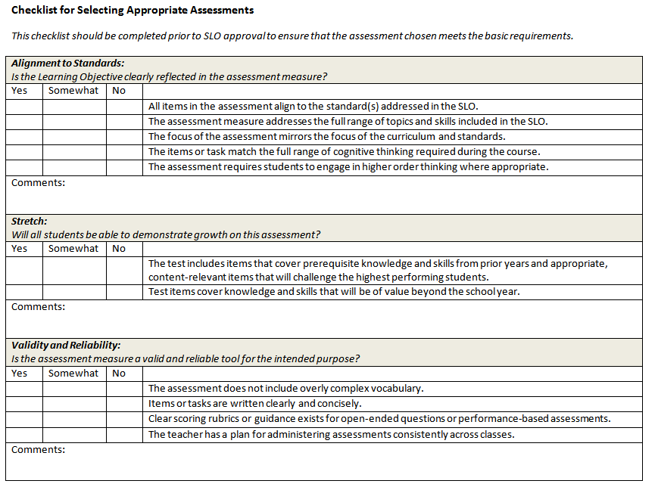
Source. Ohio Department of Education. (2012). Guidance on selecting assessments for student learning objectives (SLOs).

